General Welfare Requirement: Suitable premises, environment and equipment
Outdoor and indoor spaces, furniture and toys must be safe and suitable for their purpose.
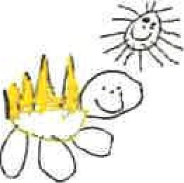
Gorran Pre School
Health and safety
3.6 Recording and reporting of accidents and incidents
(Including procedure for reporting to HSE, RIDDOR)
Policy Statement
At Gorran Pre-School Hoglets we follow the guidelines of the Reporting Injuries, Diseases and Dangerous Occurrences (RIDDOR) for the reporting of accidents and incidents. Child protection matters or behavioural incidents between children are NOT regarded as incidents and there are separate procedures for this.
EYFS key themes and commitments
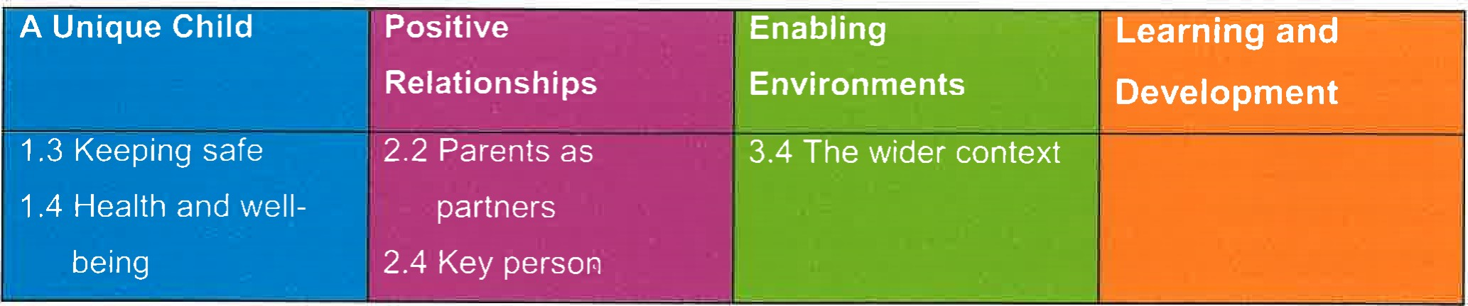

Procedures
Our accident book:
- is kept safely and accessibly; is accessible to all staff who know how to complete it; and is reviewed at least half termly to identify any potential or actual hazards.
- is completed and signed by a member of staff following an accident to a child.
The child's parent will sign the accident form when they come to collect the child.
Ofsted is notified within 14 days of any injury requiring treatment by a general practitioner or hospital doctor, or the death of a child or adult.
When there is any injury requiring general practitioner or hospital treatment to a child, parent, volunteer or visitor or where there is a death of a child or adult on the premises, we make a report to the Health and Safety Executive using the format for the Reporting of Injuries, Diseases and
Dangerous Occurrences. (Telephone number 0845 300 99 23 or submit online www.hse.gov.uk/riddor)
Dealing with incidents
We meet our legal requirements for the safety of our employees by complying with RIDDOR (the Reporting of Injury, Disease and Dangerous Occurrences Regulations). We report to the Health and Safety Executive:
- any accident to a member of staff requiring treatment by a general practitioner or hospital; and
- any dangerous occurrences. This may be an event that causes injury or fatalities or an event that does not cause an accident but could have done, such as a gas leak.
Any dangerous occurrence is recorded in our incident book. See below.
Information for reporting the incident to Health and Safety Officer is detailed in the Pre-school
Learning Alliance's Accident Record publication.
Our incident book
We have ready access to telephone numbers for emergency services, including local police. We ensure we have access to the person responsible for the premises and that there is a shared procedure for dealing with emergencies.
- We keep an incident book for recording incidents including those that that are reportable to the
Health and Safety Executive as above. These incidents include:
- break in, burglary, theft of personal or the setting's property; an intruder gaining unauthorised access to the premises; fire, flood, gas leak or electrical failure; attack on member of staff or parent on the premises or nearby; any racist incident involving staff or family on the centre's premises; death of a child, and a terrorist attack, or threat of one.
In the incident book we record the date and time of the incident, nature of the event, who was affected, what was done about it - or if it was reported to the police, and if so a crime number.
Any follow up, or insurance claim made, should also be recorded.
- In the unlikely event of a terrorist attack we follow the advice of the emergency services with regard to evacuation, medical aid and contacting children's families. Our standard Fire Safety Policy will be followed and staff will take charge of their key children. The incident is recorded when the threat is averted.
- In the unlikely event of a child dying on the premises, the emergency services are called, and the advice of these seNices are followed.
The incident book is not for recording issues of concern involving a child. This is recorded in the child's own file.
Legal framework
Reporting of Injuries, Diseases and Dangerous Occurrences Regulations (RIDDOR 1995) www.hse.gov.uk/riddor
- Further guidance
RIDDOR Guidance and Reporting Form

Other useful Pre-school Learning Alliance publications

- Accident Record (2010)
- Incident Record (2009)
This policy was adopted at a meeting of
Held on: October 2019
Date to be reviewed: October 2020
Name of signatory
Role of signatory (e.g. chair)

Gorran Pre-School Hoglets

Michelle Beard

Pre-School Leader/Nominated Person

